**Retail Management Application Using Salesforce**

1. **INTRODUCTION**
   1. Overview

Retailing encompasses the business activities involved in selling goods and services toconsumers for their personal, family, or household etc. A CRM product owner has requested tocreate two applications, one is a sales app for sales reps to use this application and storecustomers data, and the second application is a service app for service reps/agents to providesupport to customers in dealing cases. To generate business on top of the customers.

* 1. Purpose

Retail management includes all the steps required to bring the customers into the store and fulfill their buying needs. Retail management makes shopping a pleasurable experience and ensures the customers leave the store with a smile. In simpler words, retail management helps customers shop without any difficulty.

1. **ProblemDefinition & DesignThinking**

1.3 Empathy

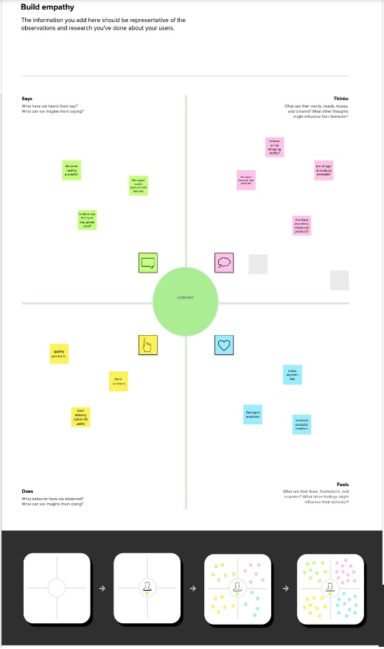

1.4Ideation &Brainstorming Map

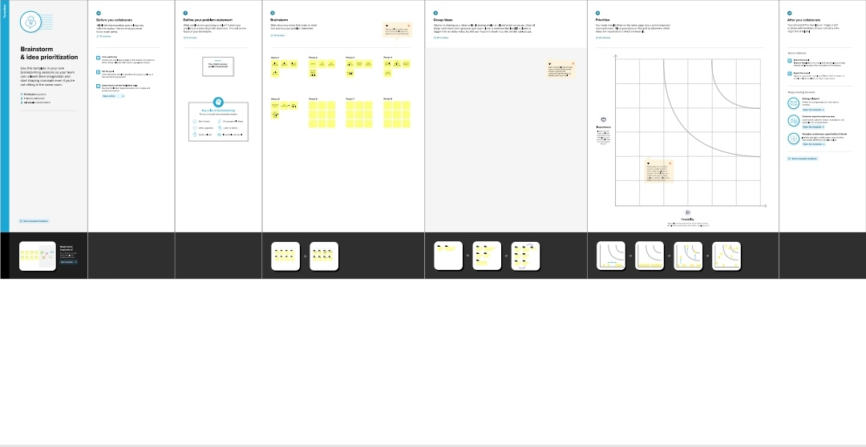

1. **RESULT**

|  |  |  |
| --- | --- | --- |
| **Application** | **Object** | **Description** |
|  | Campaign | We do promotions by using this object |
|  | Leads | We capture leads here |
|  | Accounts | We capture customers data |
| **Sales app** | Contracts | Employees data of custome |
|  | Opportunities | SMB sales orders data |
|  | Products | Here we store product details i.e electronic  types |
|  | Werehouse | We capture stocks data |
|  | Sales order | This is an actual order which has invoice  details |
|  | Dispatch /tracking | Orders dispatch related info will be stored  here |

|  |  |  |
| --- | --- | --- |
| **Application** | **Object** | **Description** |
| **Service app** | Cases | Historical problems of customers will be  stored here |
|  | Accounts | We captures customers data |

1.3 Activity &screen shot

1. 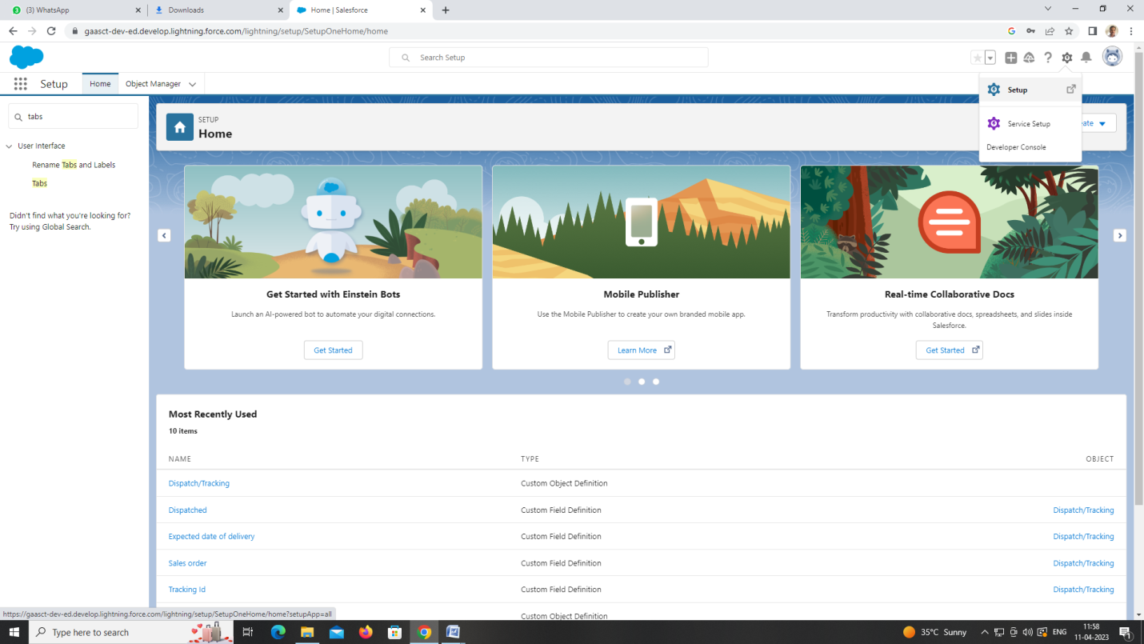

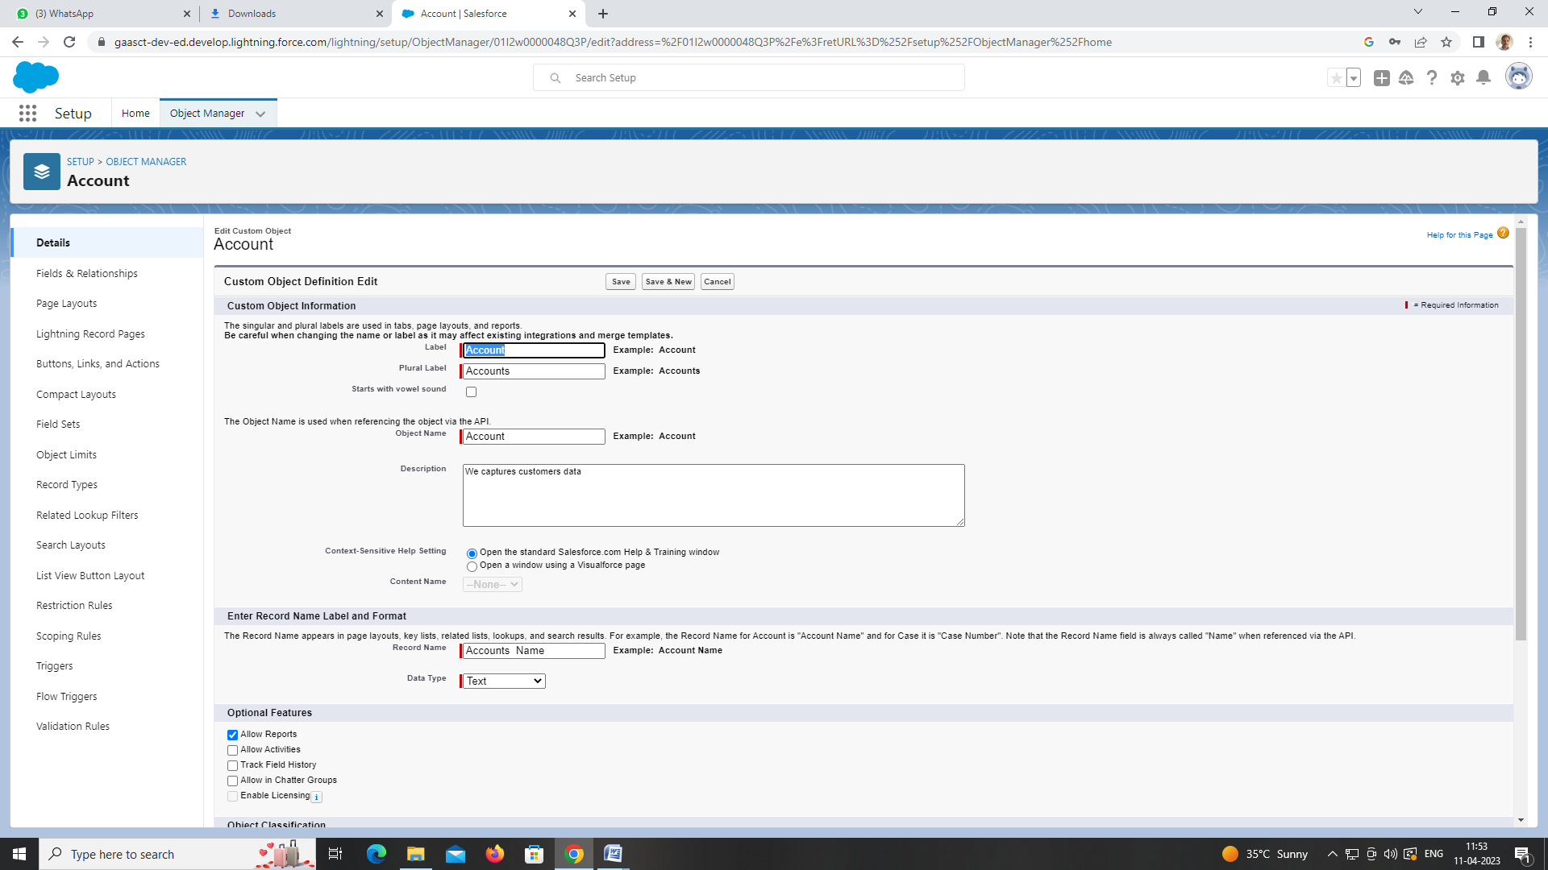

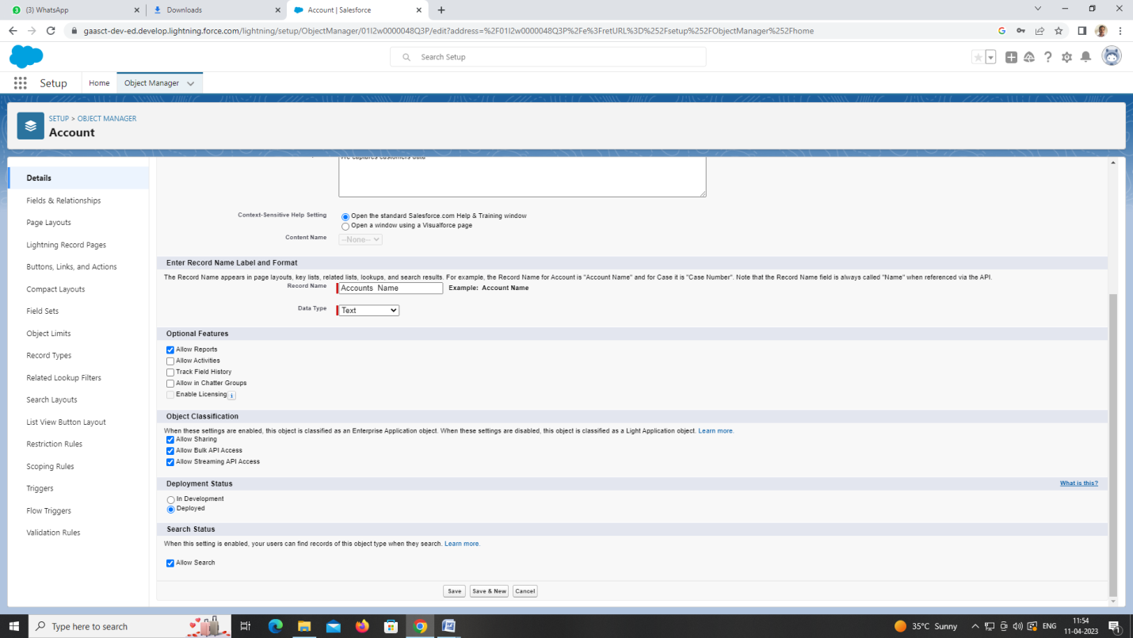

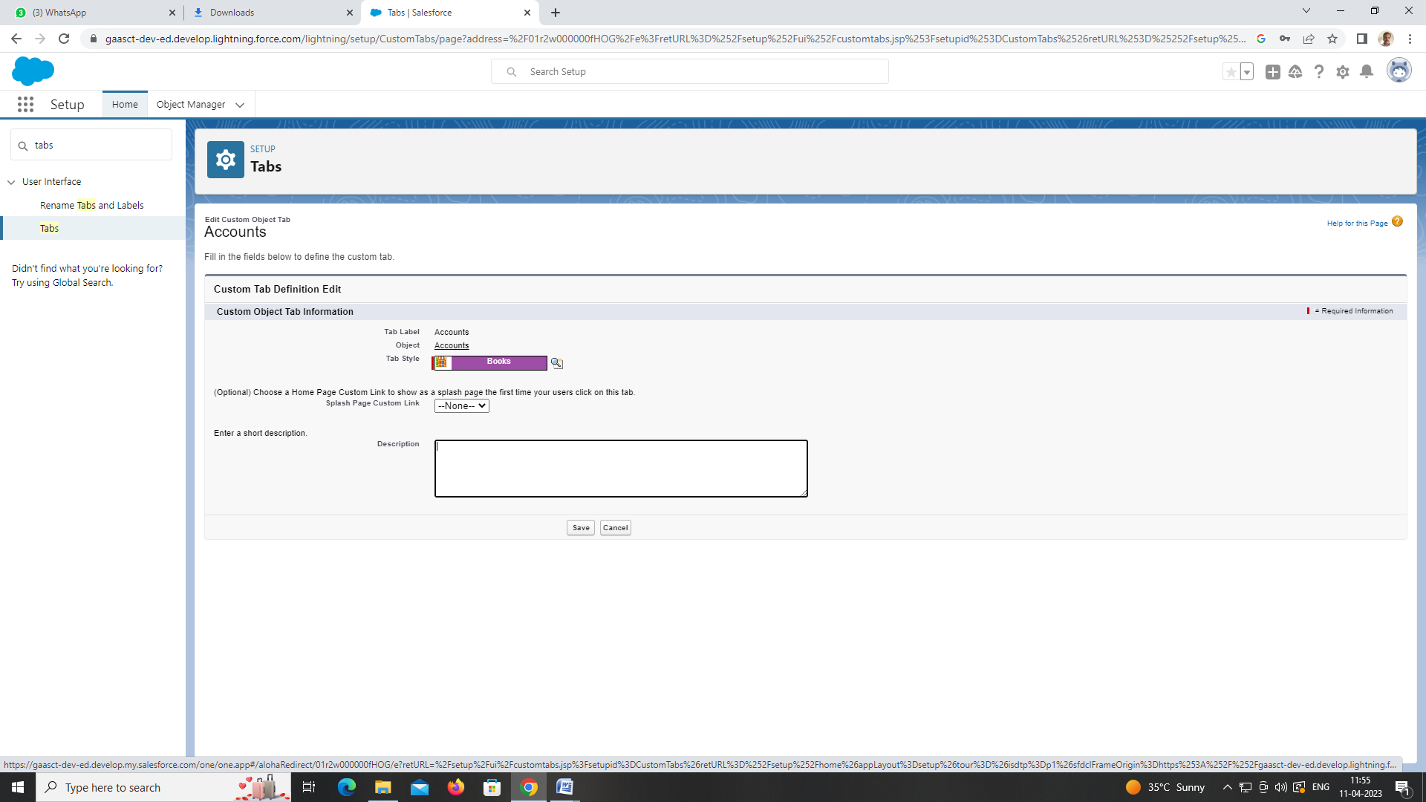

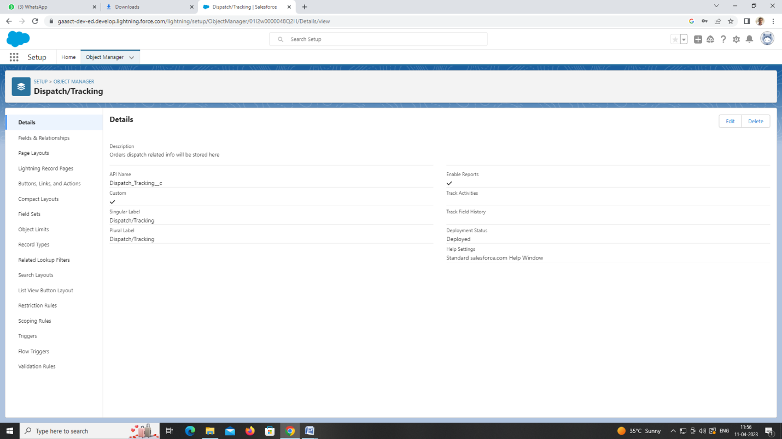

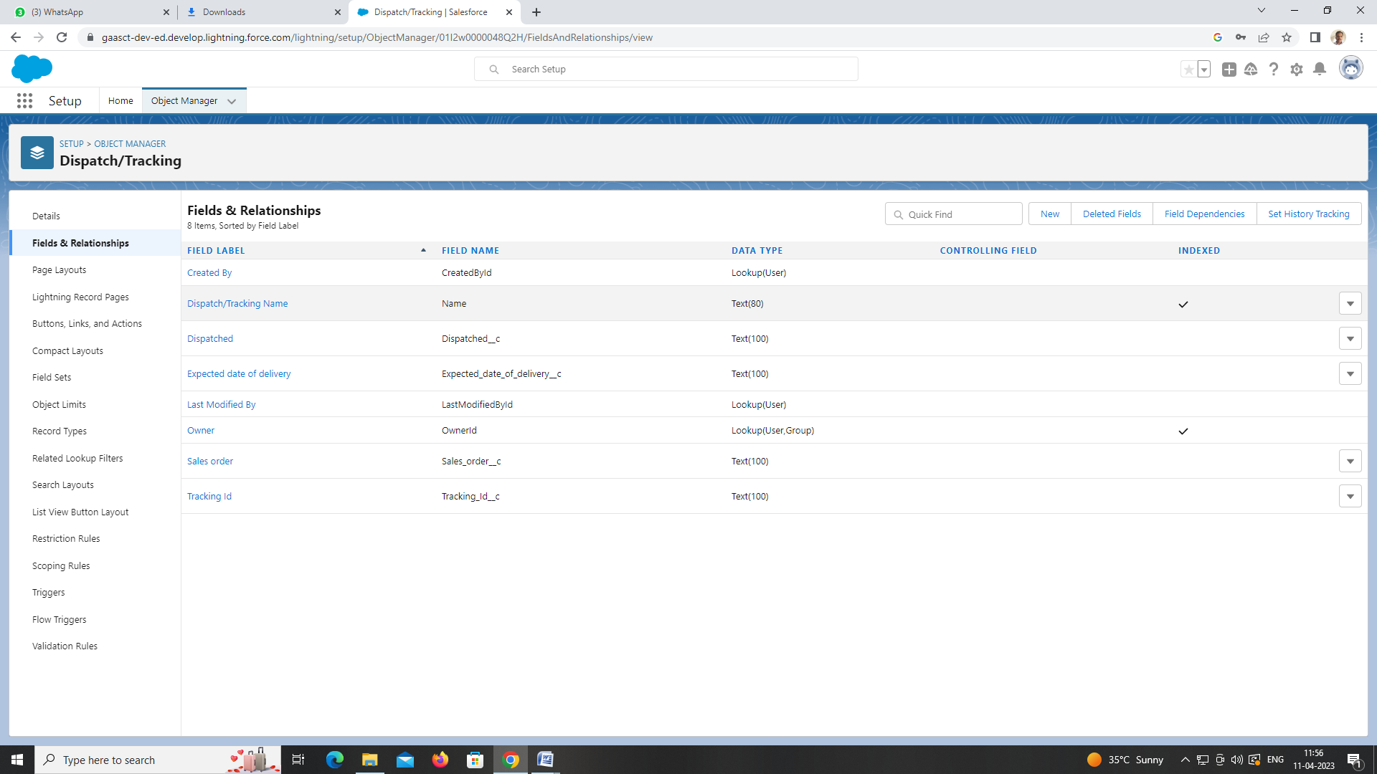

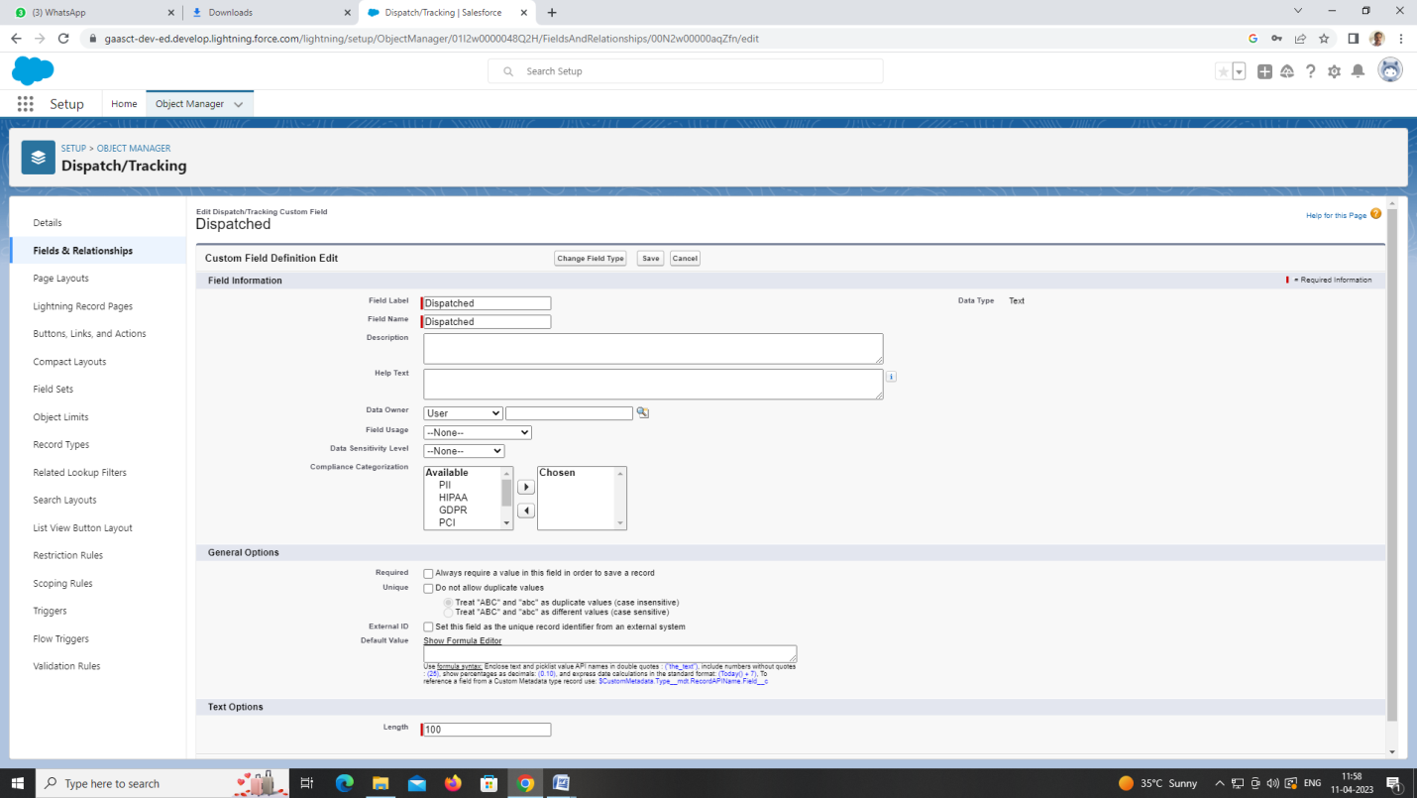

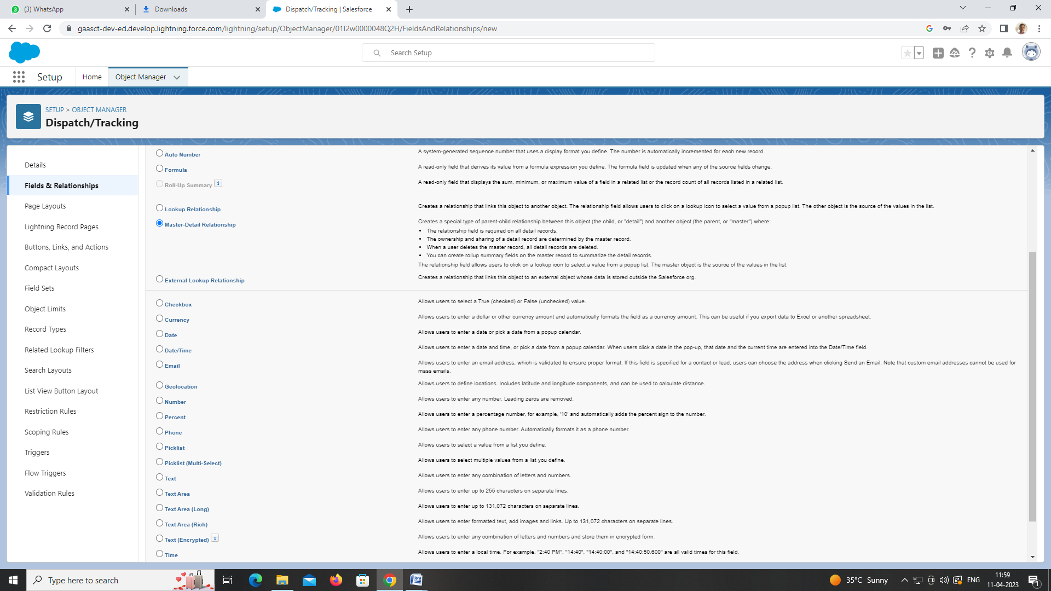

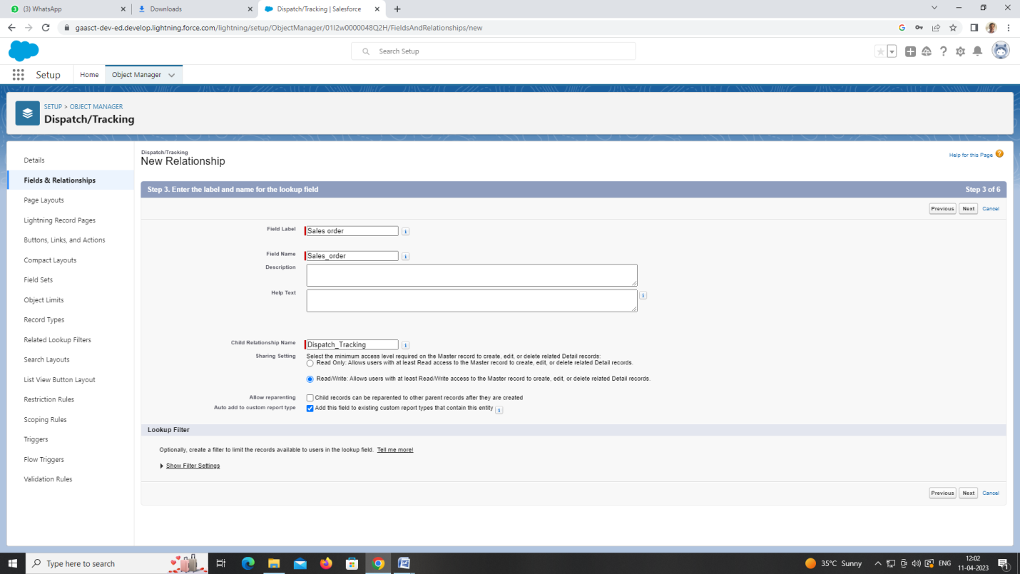

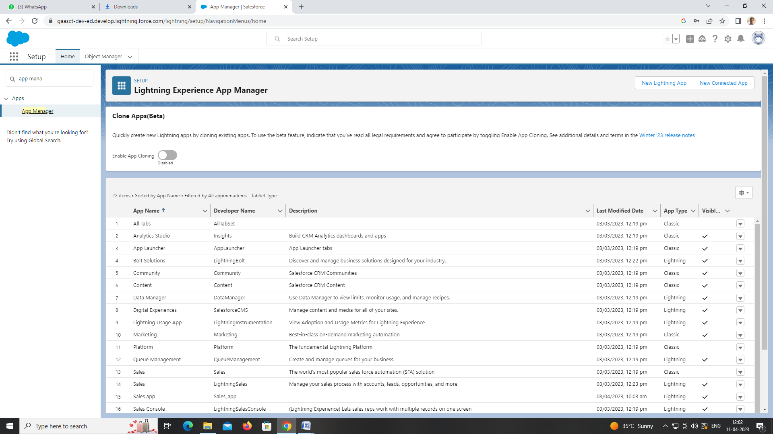

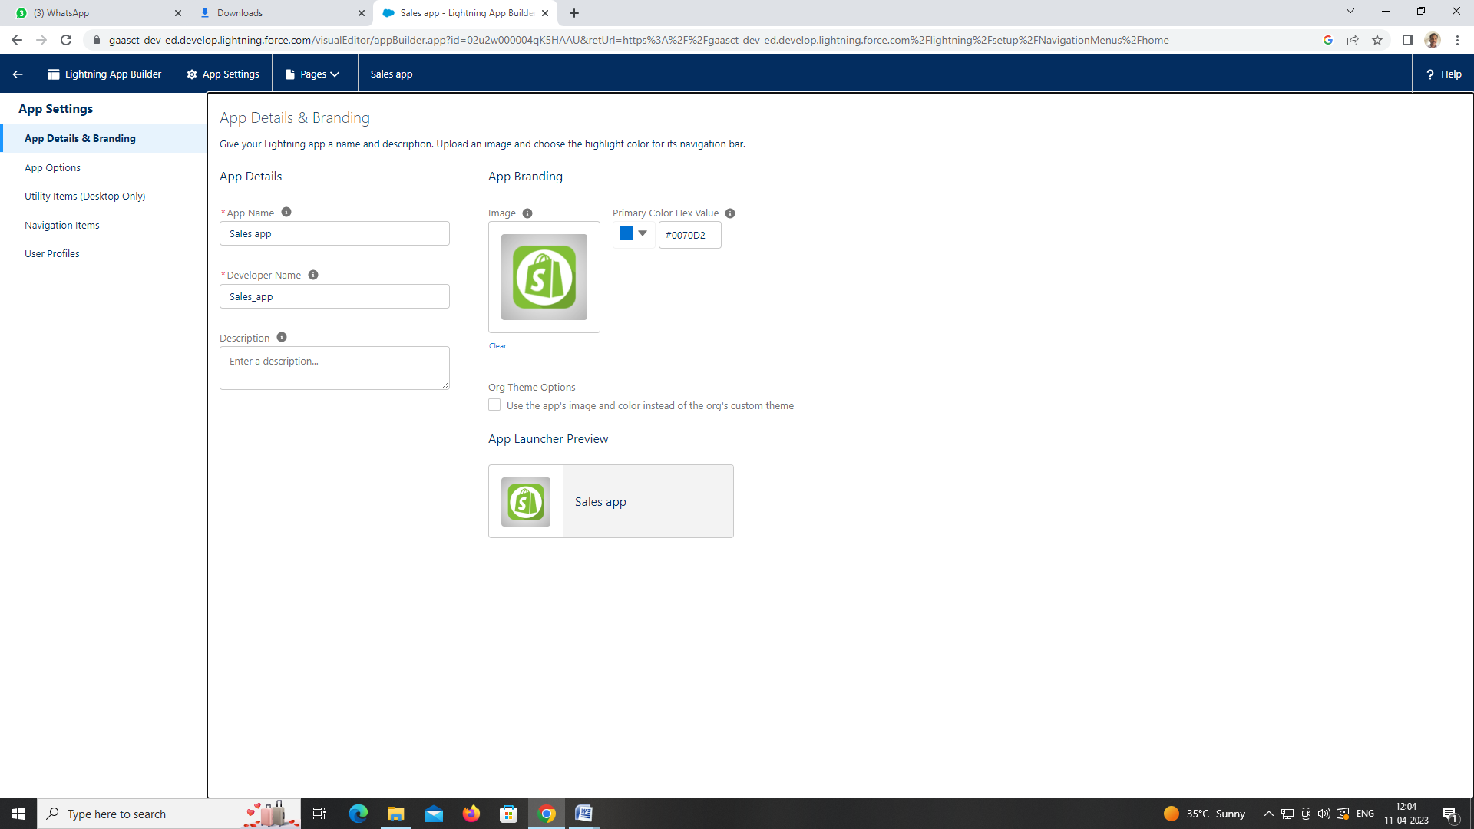

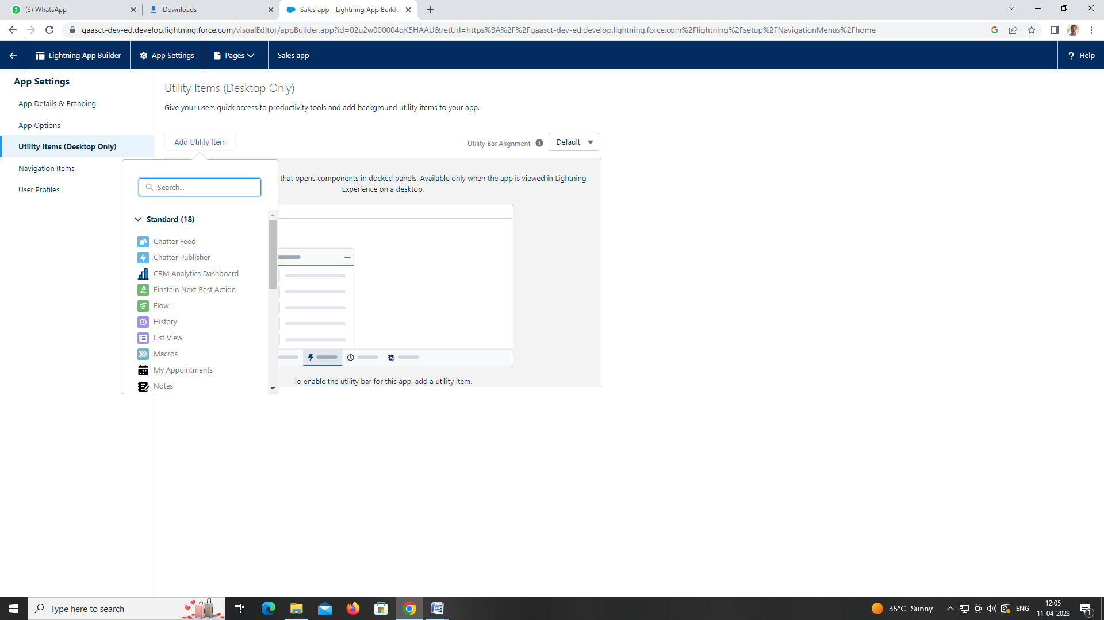

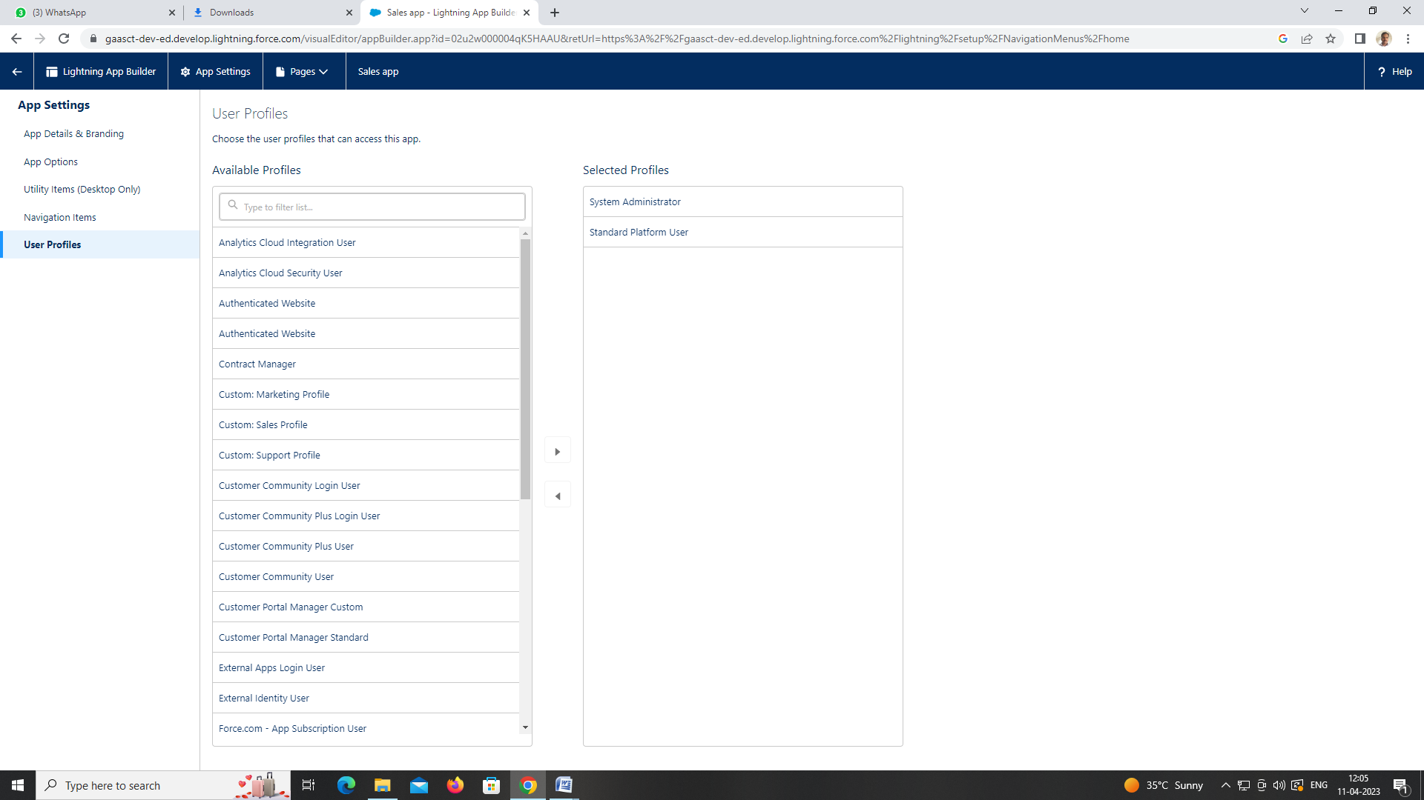

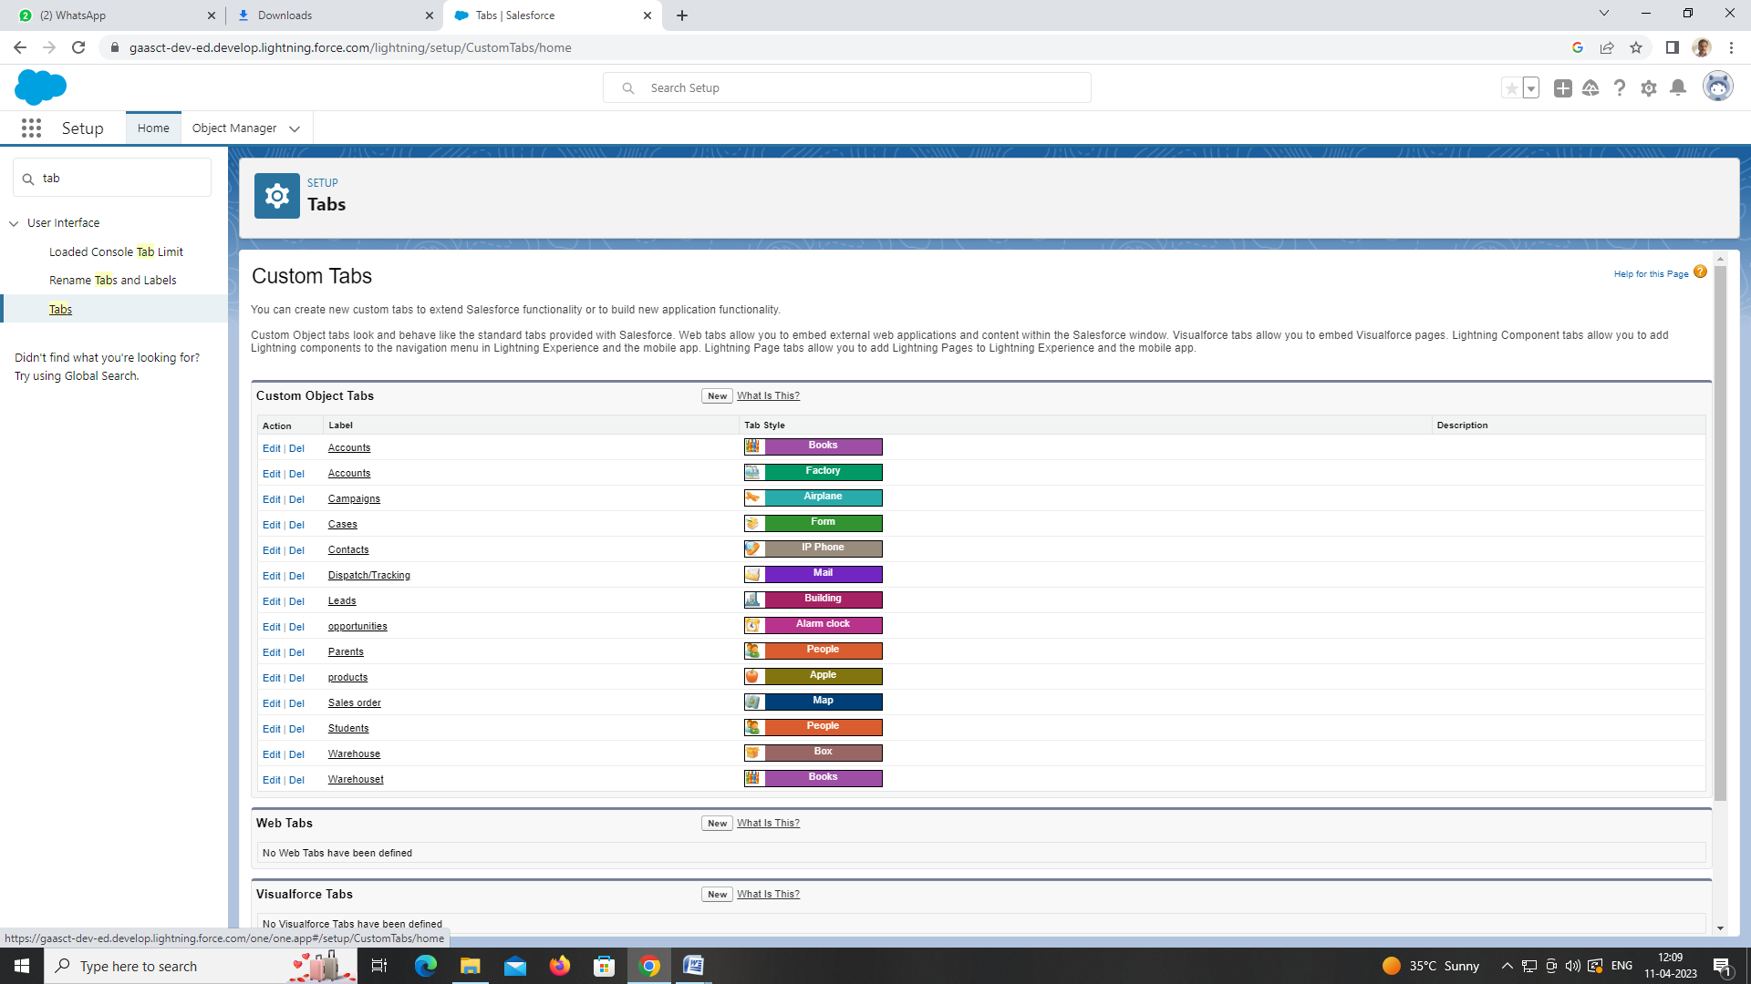

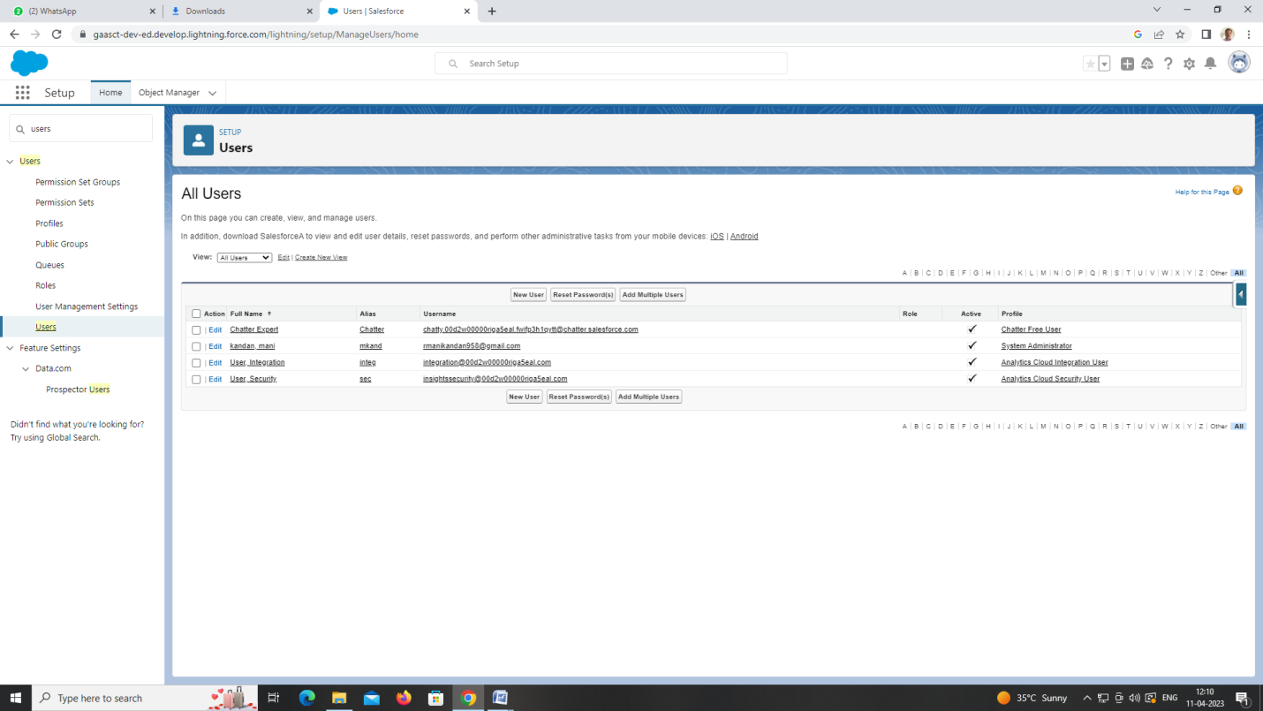

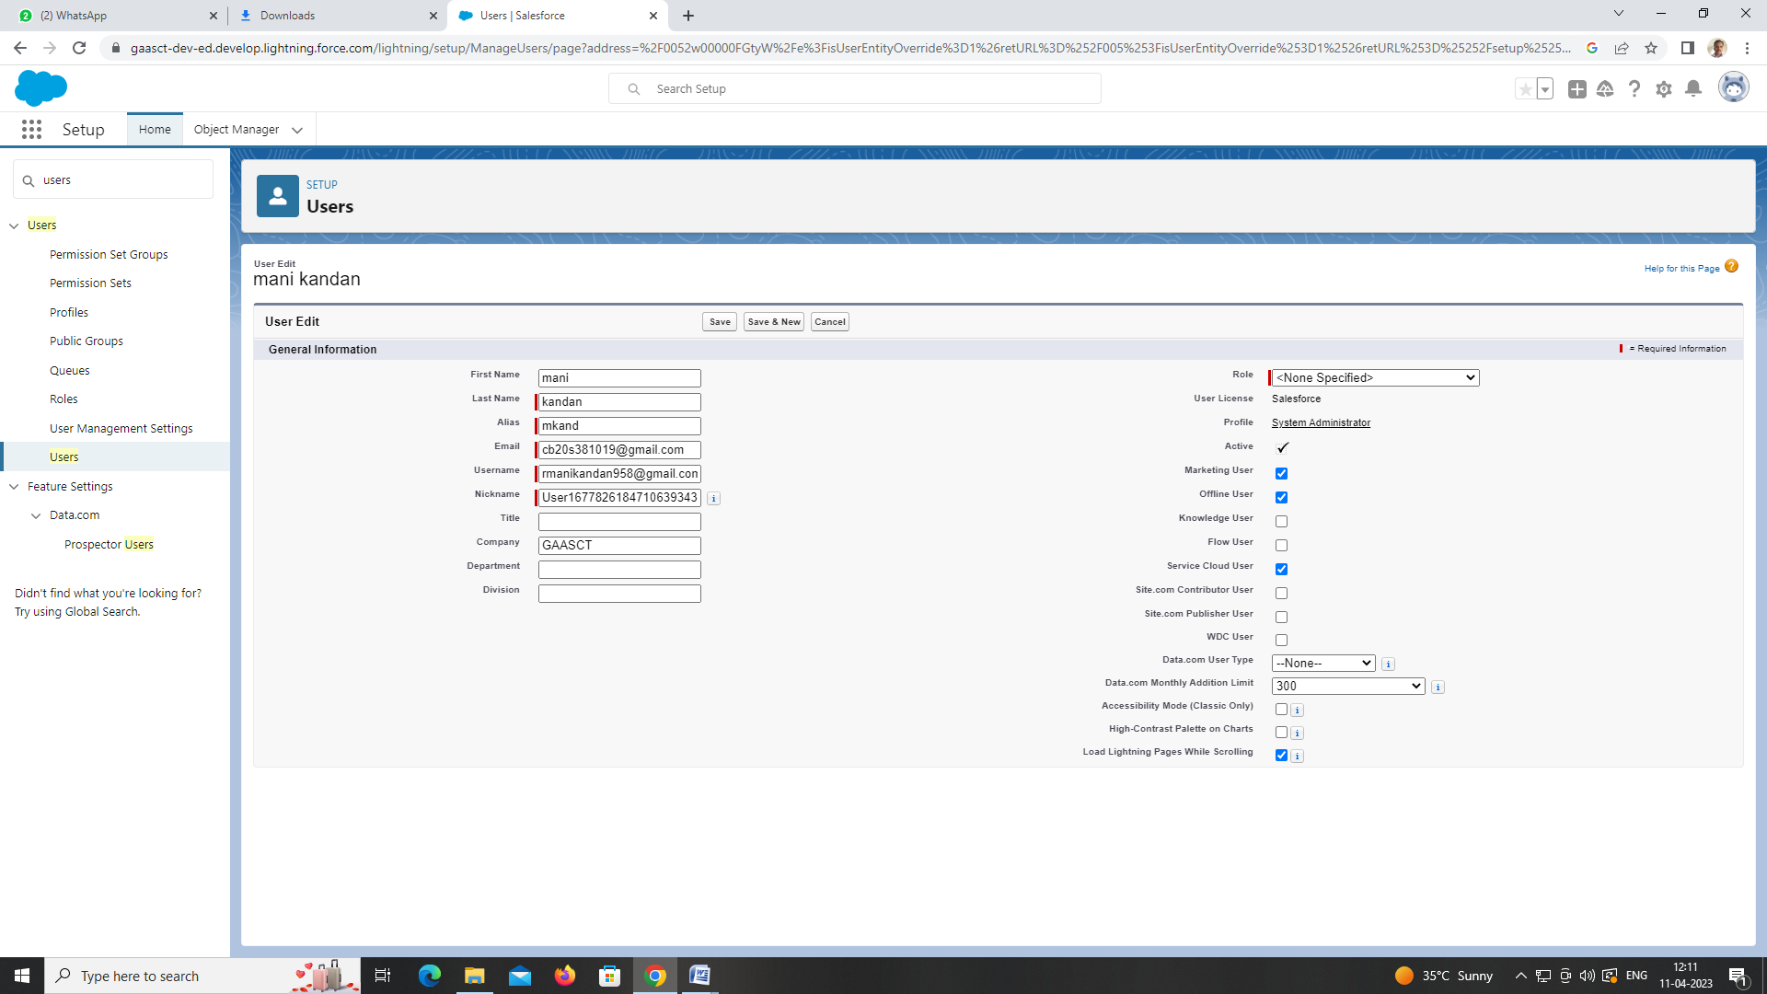

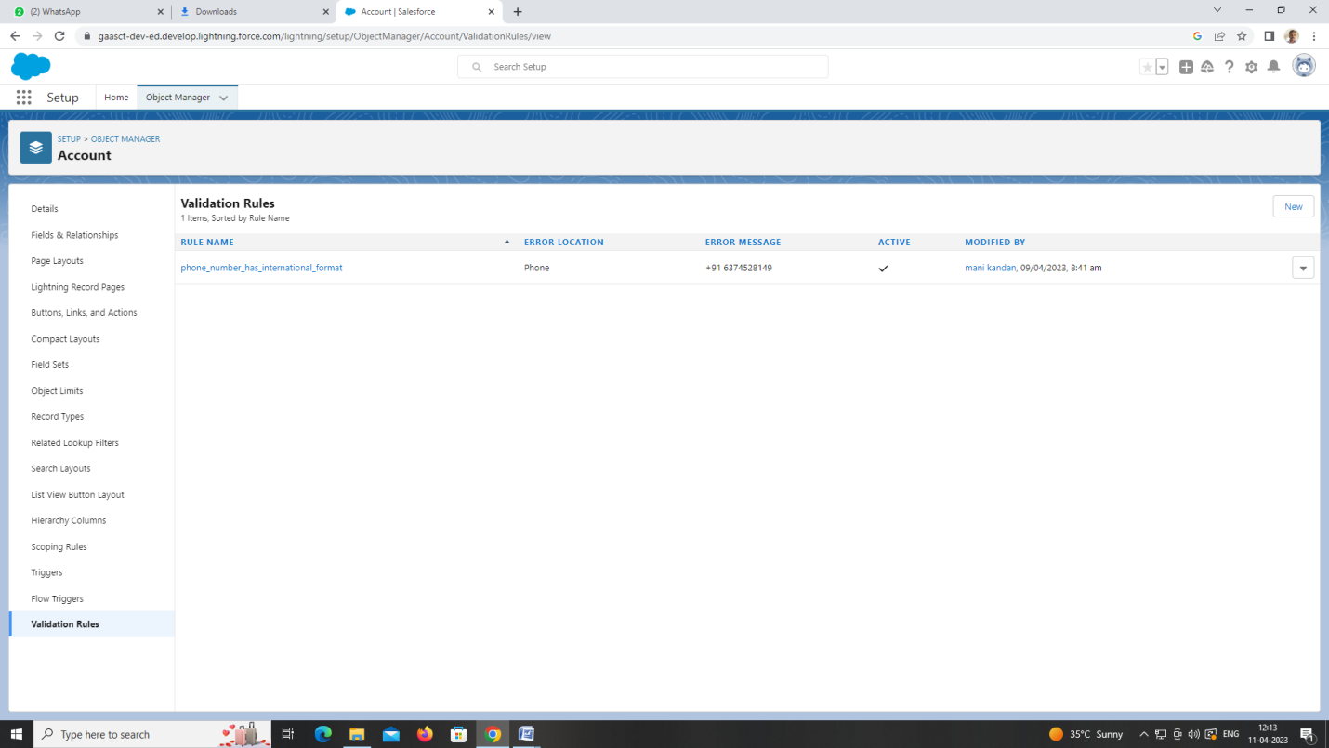

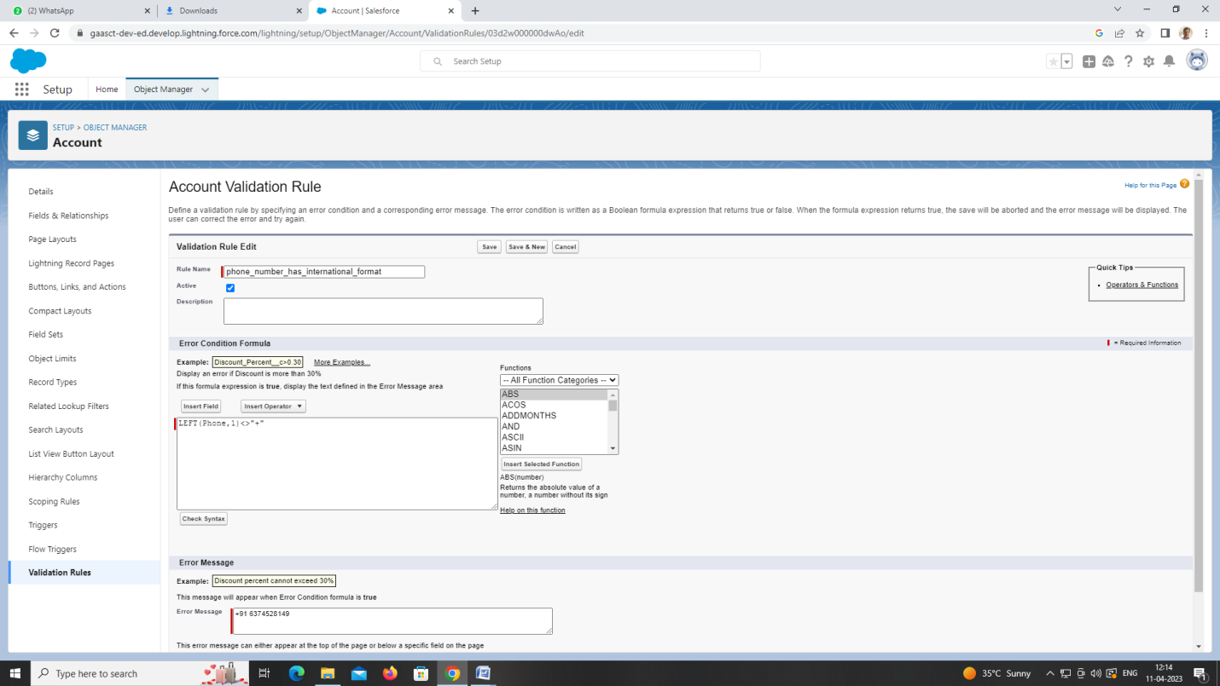

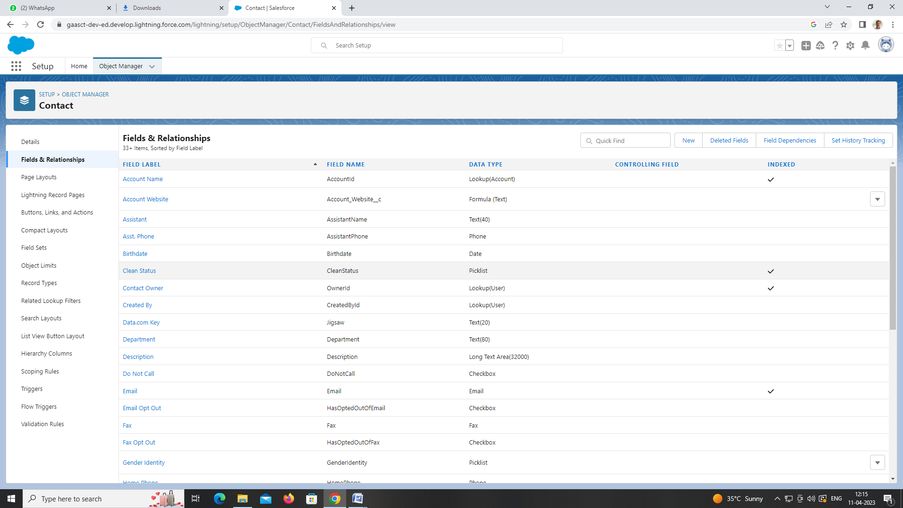

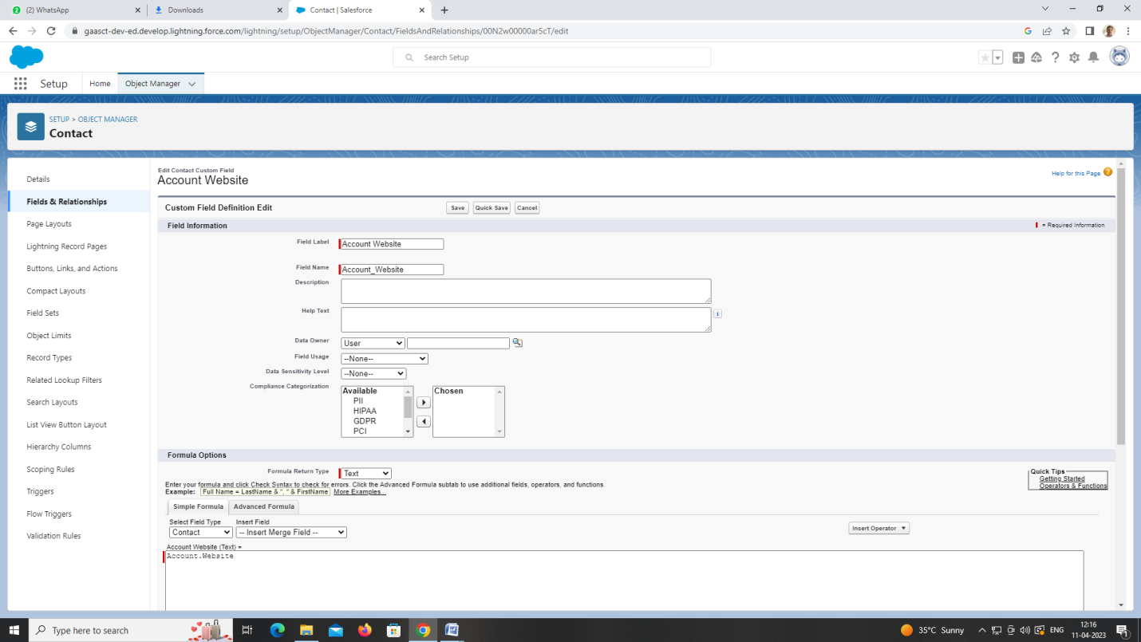

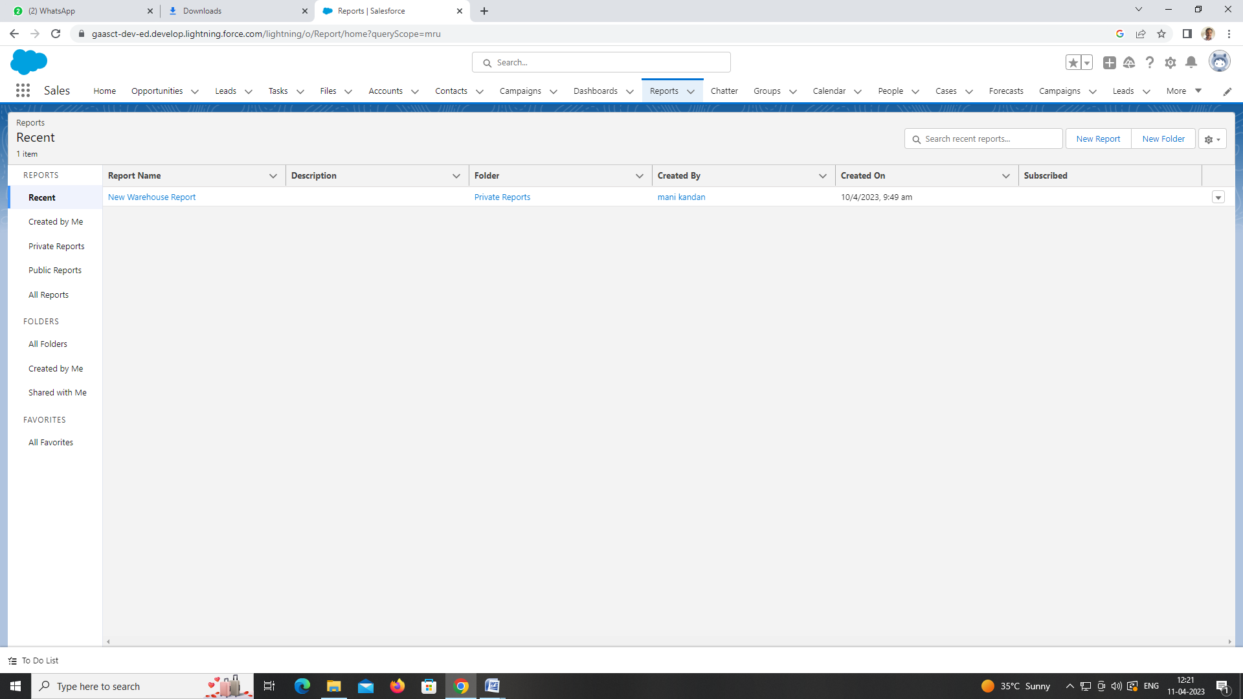

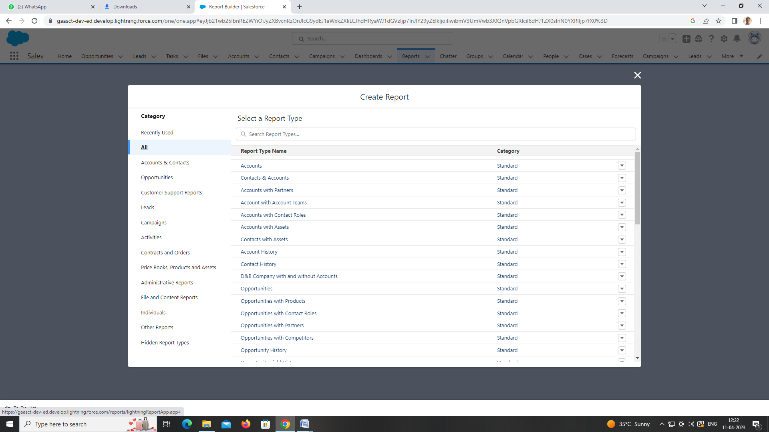

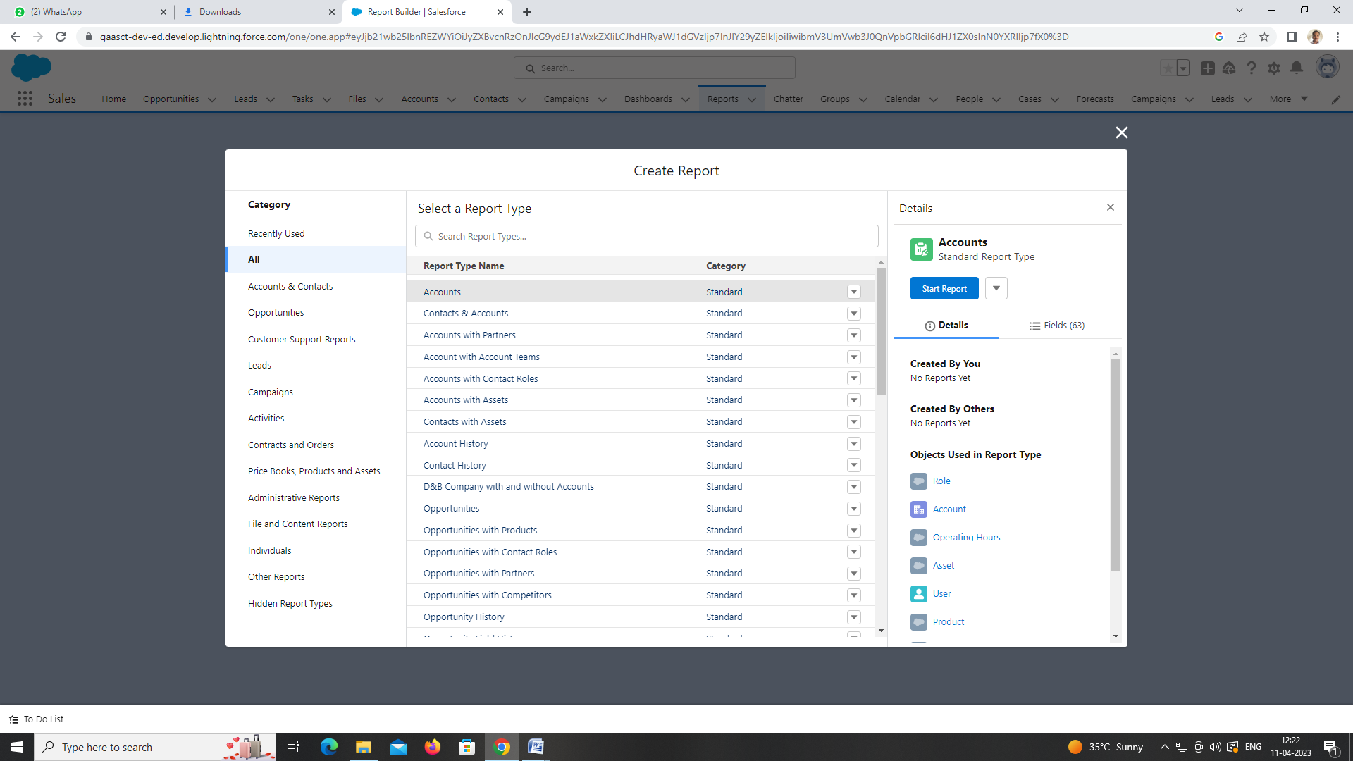

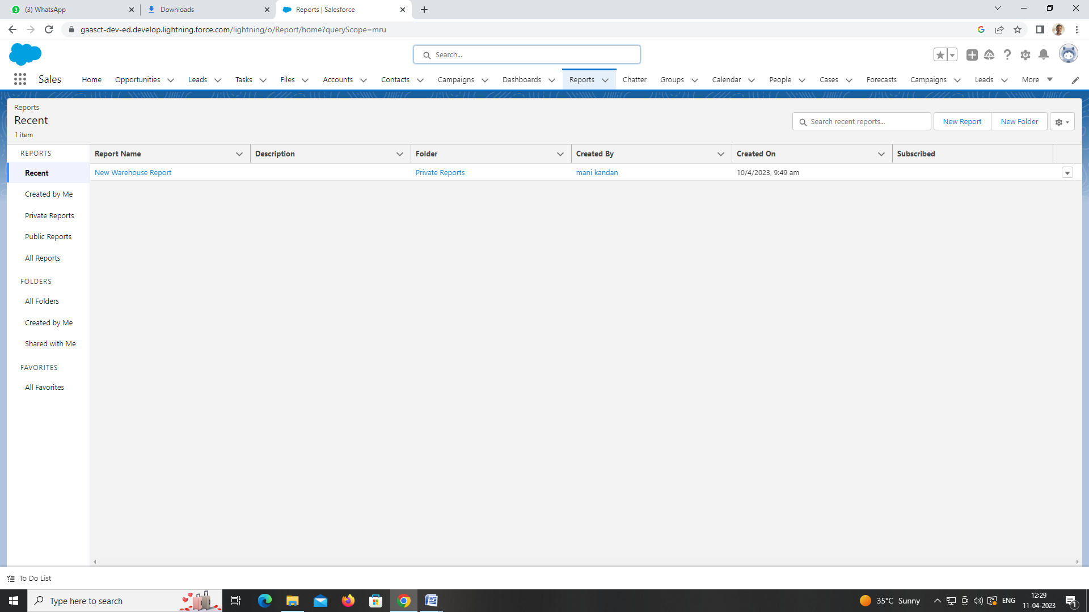

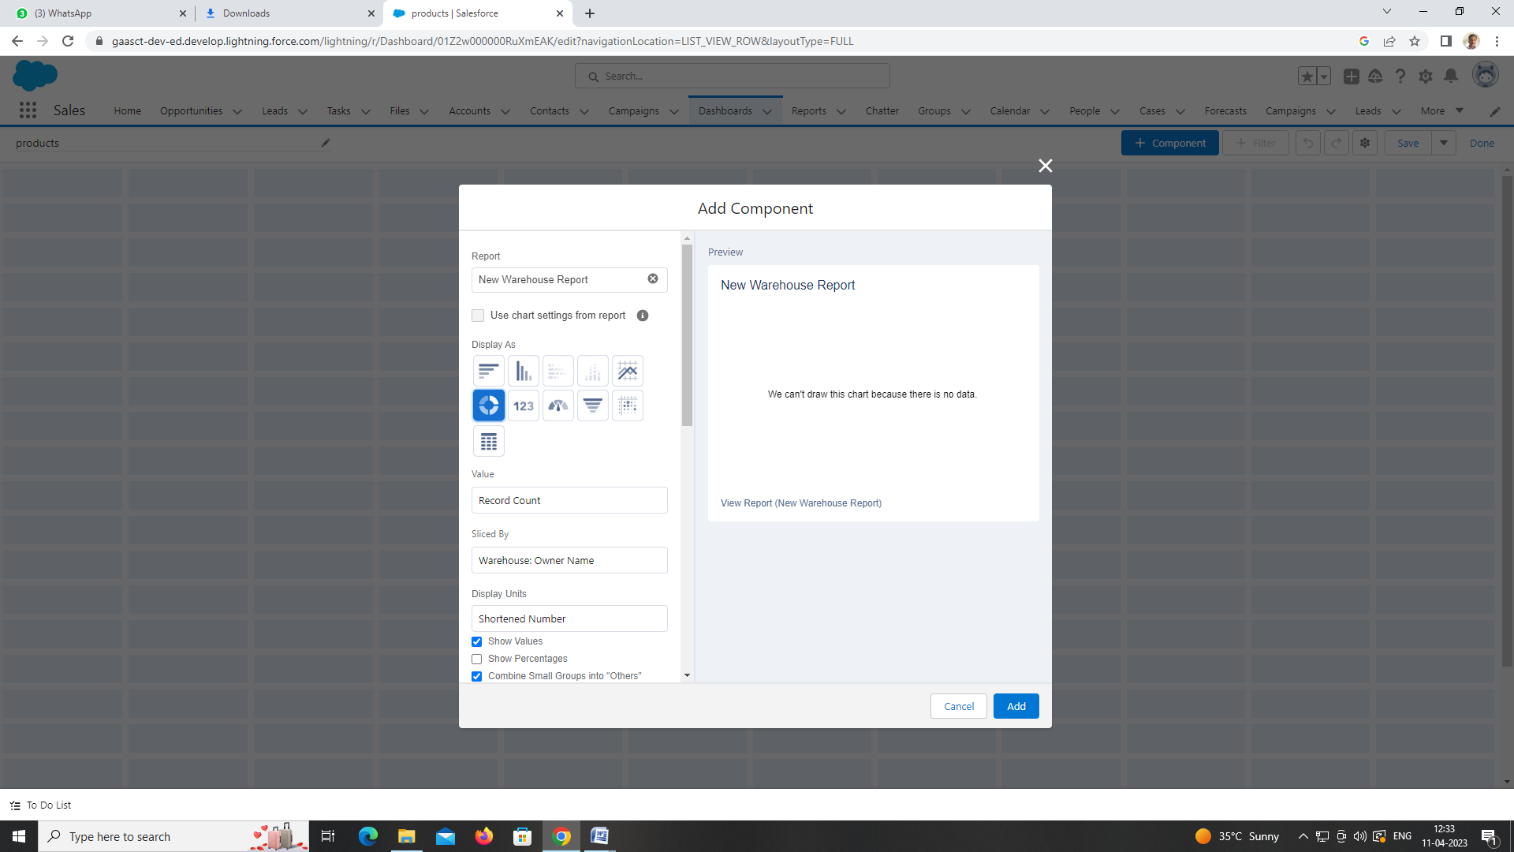

1. **Trailhead Profile Public URL**

**Team lead-https://trailblazer.me/id/mkandan65**

1. **ADVANTAGES & DISADVANTAGE**

**ADVANTAGES:**

**1. Less Capital Requirement**

It does not require huge investment to start retail business. Retailers buy goods from wholesalers in small quantity and sell to ultimate customers. It does not need large space to store goods. So, retailing can be commenced with little investment.

**2. More Profit Margin**

There is fixed margin of profit for wholesalers. Generally they earn 3% to 8%  profit on sale. But there is no fixed margin for retailers, shopkeepers may fix profit margin up to 20% in some cases.

**3. Credit Facility**

Another benefit of retailers is that they get credit facility from wholesalers or dealers. But they sell products on cash which helps to maintain adequate liquidity in the business.

**4. Better Customer Relation**

Retailing is directly linked with the customers. Retailers can understand the interests, preferences and buying behavior of customers. It helps to build better customer relation and loyalty.

**5. No Liability**

In case of faulty or defective products, the manufacturer should replace the product. So, retailers do not need to bear the loss

**DISADVANTAGES:**

**1. High Marketing Cost**

Retailers should make investment in decoration of shop and display of goods to attract more customers. So, it requires more marketing or advertising cost than wholesalers.

**2. Selling Skill Required**

It requires good selling skill to attract customers. Retailers should possess the art of good communication and convincing power to influence consumers.

**3. Very High Competition**

Another disadvantage of retailing is that there is tough competition in the market because several retailers sell similar types of products. So, it is difficult to remain in the competitive environment.

**4. No Economies Of Buying**

Retailers buy small volume of products from wholesalers. So, they miss the opportunity to enjoy he benefit of economies of buying.

**5. It Requires Proper Location**

It is difficult to find out proper location to start retail store. It requires highly dense area with fewer competitors.

**APPLICATIONS:**

1.Home

2.Industries

3.Mahl

**CONCLUSION:**

It is important to note that value is not static, but rather a dynamic concept that builds over time and can radically change due to alterations in market dynamics or consumer needs. For this reason, it is vital for retailers to identify trends that can change consumer behavior and adjust their offering accordingly.  
Retail concept should be at the core of every retailer’s strategy and therefore understanding where the customer value stems from has an enormous impact on how a retailer will succeed. Consumer value is constructed from the difference between benefits and sacrifices. In a retail setting, the objective price and the effort needed to acquire a product is the sacrifice where as value of the product and the shopping experience is the benefit received. Whenever benefits outweigh sacrifices the consumer will engage in purchasing behaviour, given that they recognise the need or desire for a product or service

**FUTURE SCOPE:**

The retail sector in the country is currently booming, providing plenty of career prospects for people with a passion for sales marketplaces, business diversification, campaigning, advertising, market research, and segmentation. With the continuous expansion of the retail industry, there is a growing demand for retail courses that will prepare students to cope with the tactics, procedures, and methods that will help them generate more sales and customer satisfaction.

Retail management has become one of the fastest-growing occupations in the industry as the economy has grown significantly. The retail industry in India is the most appealing and fastest-growing in the world, demanding an increase in competent expertise in this discipline.

It intends to create a new generation of international-caliber smart retail experts by providing them with global best practices.